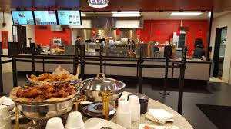

Restaurant management; Progress report 2
Yasir Almutairi
03/09/2018

Project Overview
The progress of the projects is considerably satisfactory. The major complaint we have received is that of slow running of services attributed to the new employees we had recently hired upon launch of the restaurant. This is also coupled with lack of other after services. However, this is dimmed to come to an end after consulting with various companies that train and hire restaurant employees. Since it has been rampant, complain by customers I now must ensure this is dealt with to keep the business afloat.
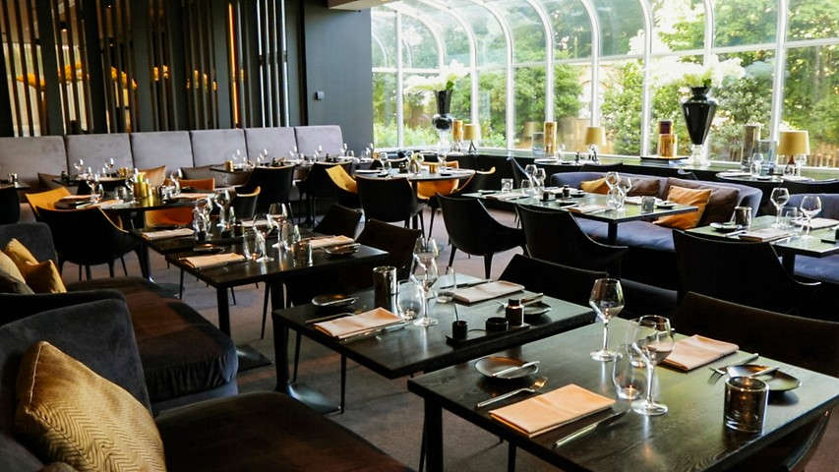
Project goal
Staging a solid customer is the main business goal for my restaurant. We realize that this will ensure we are sensitive to our client's needs and wants. This may not be easy as customers may tend to want to compare our restaurant to other big ones around by the task is out to perform. Initially, we are working on how to increase the number of staff and develop a hotline that will serve those that would like to make orders from the comfort of their homes.
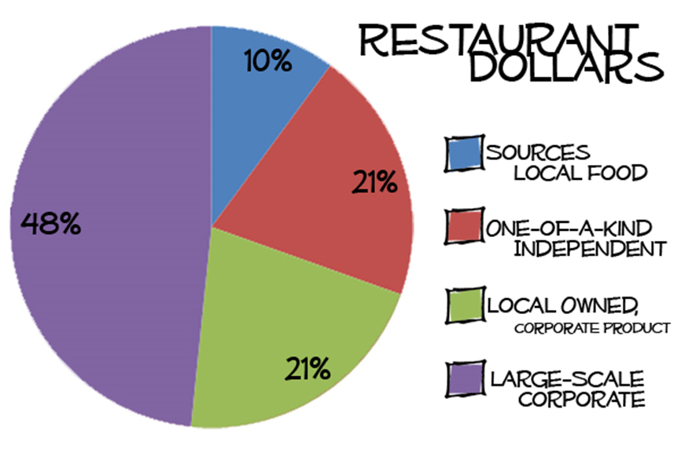
Project approach
We are liaising with company a well-known company that trains and hires staff working in restaurants. I had a meeting that will fruitfully on board close to many employees within this month and schedule others later. There was also a meeting with Telecom Co. one that will help us develop a hotline and social media platforms geared towards accessing more information on our services from customers. By all means and ways, these changes will come in to ease our operations.
Expected results
Our sales went up last month, but with the devised changes coming into place, our hopes are that these figures might double and that also we shall be able to establish ourselves better with a formidable customer base.
Resources

For now, the human power is relatively inadequate, but after the scheduled meeting this is bound to change. It should also be noted that an increase in skilled labor will mean there is sourcing of funds to pay them up and also keep the social media services alive. There are plans to borrow a soft loan from the bank that will ensure the services run smoothly in their initial days.
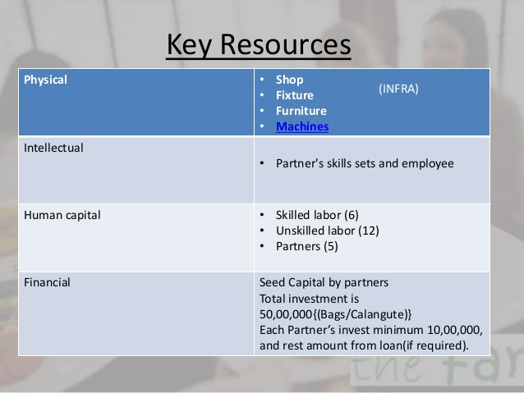

Assumption
Since the ideas are borrowed from other restaurants that are doing well in the industry, then we assume that they will fit our customer demands and enable us to work to discover other shortcomings to our success.
Milestone
Sales throughout other days of the week are to increase probably within the first month of relative changes and overall sales to be realized with profits later.

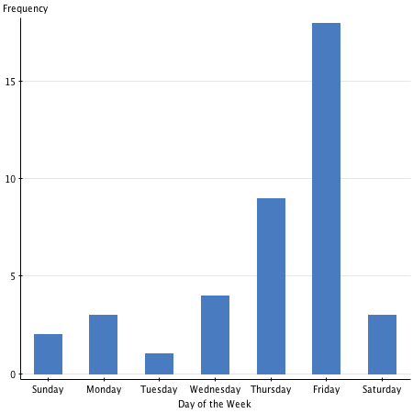
Limits and exclusions
This is a new business venture, and not much of profits is yet to be realized. This has proven to be a challenge even in endorsing other ideas and also the fact that it is under sole proprietorship which limits my access to new ideas instantly, but maybe with time a lot of profits will be realized as I incorporate other stakeholders.

References
Giousmpasoglou, C. (2016). Hotel and restaurant management education.
Han, H., & Hyun, S. S. (2017). Impact of hotel-restaurant image and quality of physical-environment, service, and food on satisfaction and intention. International Journal of Hospitality Management, 63, 82-92.
Ruiz-Molina, M. E., Gil-Saura, I., & Berenguer-Contrí, G. (2014). Information and communication technology as a differentiation tool in restaurants. Journal of Foodservice Business Research, 17(5), 410-428.
Silva, J. (2017). U.S. Patent No. 9,805,401. Washington, DC: U.S. Patent and Trademark Office.
Walker, J. R. (2013). The restaurant: from concept to operation. Wiley Global Education.
Zheng, C., & Forgacs, G. (2017). The emerging trend of hotel total revenue management. Journal of Revenue and Pricing Management, 16(3), 238-245.

